Chapter 8, Solution 46.

Using Fig. 8.93, design a problem to help other students to better understand the step response of a parallel RLC circuit.

Although there are many ways to work this problem, this is an example based on the same kind of problem asked in the third edition.

Problem

Find i(t) for t > 0 in the circuit in Fig. 8.93.

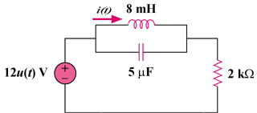

Figure 8.93

Solution

For t = 0-, u(t) = 0, so that v(0) = 0 and i(0) = 0.

For t > 0, we have a parallel RLC circuit with a step input, as shown below.

2 kΩ
i
+
v
−
8mH
5μF
6mA

- = 1/(2RC) = (1)/(2x2x10³ x5x10⁻⁶) = 50

ω_{o} = 1/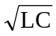 = 1/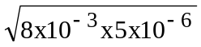 = 5,000

Since α < ω_{o}, we have an underdamped response.

s_{1,2} = 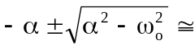 -50 ± j5,000

Thus, i(t) = I_{s} + [(Acos5,000t + Bsin5,000t)e^{-50t}], I_{s} = 6mA

i(0) = 0 = 6 + A or A = -6mA

v(0) = 0 = Ldi(0)/dt

di/dt = [5,000(-Asin5,000t + Bcos5,000t)e^{-50t}] + [-50(Acos5,000t + Bsin5,000t)e^{-50t}]

di(0)/dt = 0 = 5,000B – 50A or B = 0.01(-6) = -0.06mA

Thus, i(t) = {6 – [(6cos5,000t + 0.06sin5,000t)e^{-50t}]} mA

